**DEPARTMENT**

**OF**

**ELECTRICAL AND ELECTRONICS ENGINEERING**

**SELF STUDY ASSIGNMENT – 2**

**(JOURNAL READING & REPORT)**

**20EE4401 – LINEAR INTEGRATED CIRCUITS AND ITS APPLICATIONS**

**Name : MENAGA SRI.SB**

**Register No. : 811722105029**

**Year / Sec : II**

**Marks Awarded:**

|  |  |  |  |  |  |  |
| --- | --- | --- | --- | --- | --- | --- |
| **Objective (2)** | **Literature Survey**  **(3)** | **Problem Analysis (4)** | **Solution and Results**  **(4)** | **Methodology adopted**  **(4)** | **Conclusion and References**  **(3)** | **Total**  **(20)** |
|  |  |  |  |  |  |  |

|  |  |  |  |
| --- | --- | --- | --- |
| **Assignment Topic** | **CO** | **PO addressed** | **BTL Level** |
| Design of Low Power, High Gain Fully Differential Folded Cascode Operational Amplifier for Front End Read Out Circuits . | CO2& CO3 | PO7, PO8, PO10&PO12 | BTL 4 |

**Objective:**

The Front end read out circuits are major block in the implementation of Capacitive MEMS accelerometer. Front end read-out circuits comprises of preamplifier block containing folded cascode fully differential operational amplifier which are required for the signal conditioning of the signals received from the MEMS sensors. The op-amps are prime elements in design and implementation of mixed signal integrated circuits.

The high gain and low power of the designed circuits helps in the designing of high precision IC’s for numerous application. Amongst the available topologies folded cascode topology plays vital role in the design and development of low power, high gain read out circuits.

**Operational Amplifier for Read Out Circuit :**

The read out circuit is important component of MEMS. The output which is emitted from the MEMS Sensor portion of the system is usually having number of limitations like Low power level of Output Signal, More Noise interference, Low Sensitivity, Low Fidelity, Usually output is analog in nature and thus can’t be fed to Digital blocks like Filters and different nature of output signal like capacitive change, frequency variation, optical variations etc.

The read-out circuits are usually implemented after the Sensor block of the MEMS system so that the signal conditioning can be easily accomplished.

**Block Diagram :**



**Differential Folded Cascode Operaional Amplifier :**

It is well known phenomenon that the design of the structure, exhibiting low power dissipation and an excellent value of open loop DC gain is itself a challenging task as there is a tradeoff between open loop DC gain, power and other performance parameter.

However, these challenges have been studied by the various circuits. The various performance parameter which are majorly concerned are analyzed by taking various electrical characteristics into consideration namely: load capacitance, power supply voltage, open loop gain, ICMR, UGB, PM, output swing etc.

Majorly op-amps are concerned with the task of amplification, buffering and filtering. A well-known phenomenon about the operational amplifier is that they when implemented in the single stage mode, are faster & have extraordinary frequency response compared to the multi stage topology.

Since single stage op-amp doesn’t satisfy the nominal values of the small signal voltage circuit thus they might not be able to curb the effects of non-linearity in the open loop scenario. This all leads to the mismatch in certain results which were intended . Thus op-amps must exhibit wide range of phase margin in order to achieve high stability. For the achievement of better stability either frequency compensation technique or the single stage op-amps are used without compensating or compromising on the open loop dc gain aspect. All this is achieved with the help of folded cascode structure topology.



**Circuit Diagram :**

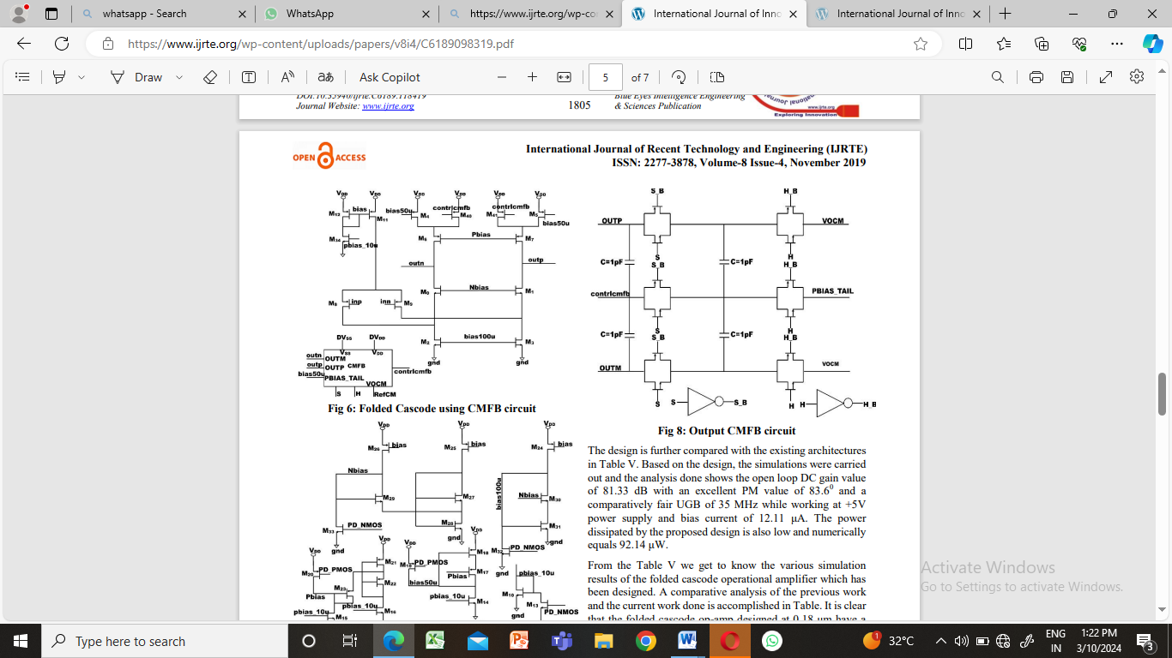

**Characteristic Curve for Cascode Operational Amplifier :**

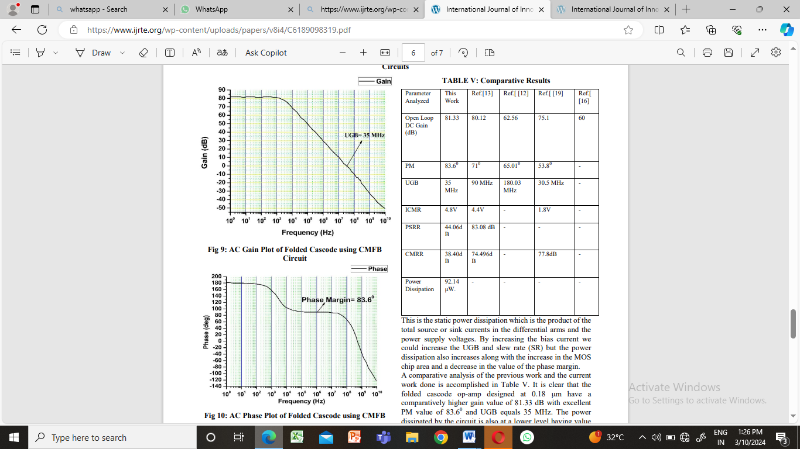



**Conclusion:**

This paper presents the design of the low power, high gain folded cascade operational amplifier for the front end read-out circuits using 0.18 μm CMOS technology. Based on the design, the simulations were carried out and the analysis done shows the open loop DC gain value of 81.33 dB with an excellent PM value of 83.60 and a comparatively fair UGB of 35 MHz while working at +5V power supply and bias current of 12.11 μA. The power dissipated by the proposed design is also low and numerically equals 92.14 μW. The achieved results in this paper for the proposed approach presents high dynamic range along with very good noise performance.

**References :**

1. Qu, H.” CMOS MEMS fabrication technologies and devices.” Micromachines, vol.7 no.1, pp.14, 2016.

2. C. Lu, M. Lemkin, B.E. Boser. “A Monolithic Surface Micromachined Accelerometer with Digital Output.” in IEEE J. Solid-State Circuits, vol. 30, pp. 1367-1373, Dec. 1995.

3. University of California, Berkeley. Berkeley Sensor & Actuator Center. B.E. Boser.“Electronics for Micromachined Inertial Sensors.”, Berkeley, CA., 1997